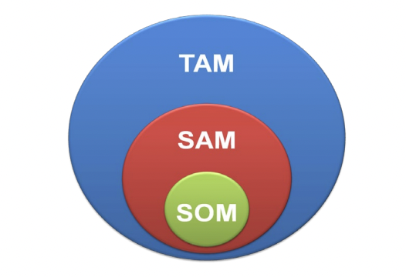
Total Available Market: Everyone who can use our nanoparticle based water pik product. (current water pik users, doctors, hygienists, anyone who cares about their oral health and are open to try more effective oral hygiene products)
Serviceable Available Market: People who want to buy our product and we can reasonably reach.
(current water pik users, doctors, hygienists)
Serviceable Obtainable Market: The portion of the serviceable available market that we want to target.
(doctors, hygienists)

- the global dental water flosser market value stood at US$ 827.4 Mn in 2021 and is anticipated to reach US$ 1.4 Bn by the end of 2031
- North America: 40% of the market
- Waterpik’s revenue is estimated to be around $104.8 million to $198.47 million (https://growjo.com/company/Water_Pik_Technologies)
- (https://my.apps.factset.com/navigator/company-security/private-snapshot/06T093-E)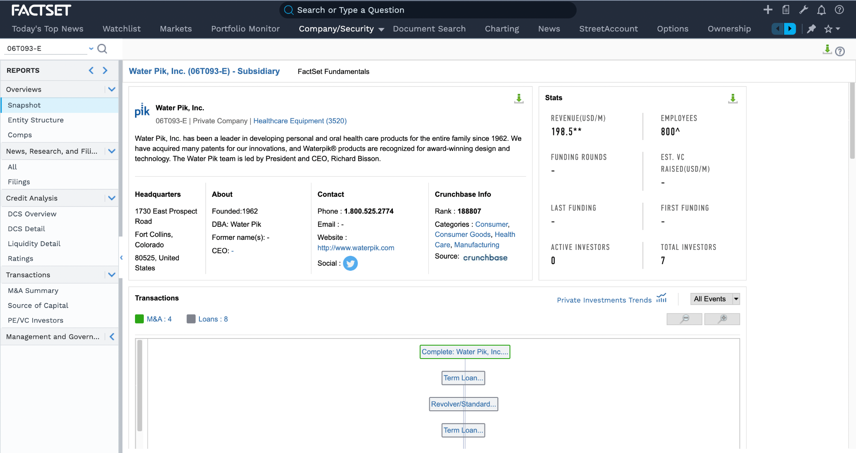

https://www.bu.edu/researchsupport/files/2022/04/Market-sizing_Meet-SAM-and-TAM.pdf

https://www.yahoo.com/now/dental-water-flosser-market-reach-203300151.html?guccounter=1&guce_referrer=aHR0cHM6Ly93d3cuZ29vZ2xlLmNvbS8&guce_referrer_sig=AQAAAFzxUSkp70Ka6c-RBP1Rs_NQc8kfvx0Sv0mcR1EyK05JtKIdg1GFQkI6EAYLl7nvMKjqoT7pNvXzD07Je5-Dcf3QFLRFVSxfrCwEplo78To_EXH529bkL6s98oXjXnXMOcXQI00zI4lhSvUZkVd4WFktrwFaQfpVNg0h3WMyuHEX

https://www.grandviewresearch.com/industry-analysis/water-flosser-market

TAM: US population 331 million
SAM: 8.274 million ($827.4 million/100 = 8.274 million)
SOM (WaterPik): 1.985 million (198.5 million/100 = 1.985 million)
SOM (Dentist & Hygienist) : 2.175 million (207,190*3500*0.01*30%=2,175,495)

